# ***Game Artist Job Research – PDPP***

## *Job 1 – Senior 3D Artist*

<https://www.amiqus.com/job/senior-3d-artist-jobid-5521>

This advert focusses on providing details of the role the applicant will have in the team while also highlighting some of the skills required, as shown in the second paragraph: *“As an exceptional communicator, you will be experienced in mentoring staff, creating stunning models and be responsible for delegating and managing outsource studios”.* The requirements for this job require a lot of experience using several pieces of software used for creating and texturing 3D models, as well as extensive experience working specifically on mobile titles, which is appropriate as this is a senior position. These requirements focus only on technical skills and experience, compared to other listings which also list practical, team working and social skills in their requirements section.

## *Job 2 – Senior 2D Concept Artist*

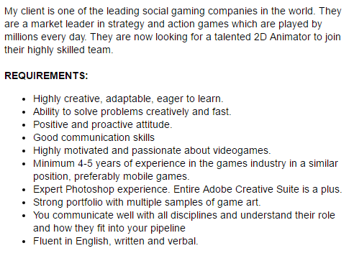<http://jobs.gamesindustry.biz/opm/spain/uk-and-europe/senior-2d-concept-artistandndash--spain-andndash--salary-doe---relocation-andndash--f2p-games-id89855>

This advert describes the client and the work they have done in the past without going too much into detail about the type of work which the job entails. The requirements focus on general skills for a good work environment, as well as details about the experience required. The client wants a lot of experience in the industry but is not as focussed on requiring mobile experience. This job also focusses on just Photoshop experience, and so it does want the applicant to be an expert. This is to be expected as this is a concept artist position and so the focus is on designing and drawing characters, assets and environments in detail.

## *Job 3 – Junior 3D Game Artist*

<https://www.reed.co.uk/jobs/junior-3d-game-artist/31576059?utm_medium=aggregator&utm_source=glassdoor&utm_term=REG&rx_campaign=glassdoor20&rx_group=101239&rx_job=31576059&rx_source=Glassdoor&rx_medium=cpc>

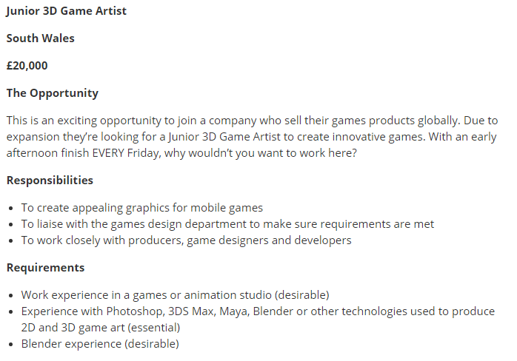This advert gives a small breakdown of responsibilities, requirements and the job benefits. The wording on this advert is quite informal compared to other adverts – *“With an early afternoon finish EVERY Friday, why wouldn’t you want to work here?”,* which could be because this advert is aimed at junior artists compared to senior artists. Even though this is a junior position, experience in a studio is still listed as a desirable requirement, but the main requirement is knowledge and experience using industry software.

## *Job 4 – UI Technical Artist*

<http://www.datascope.co.uk/job-details/all-games-jobs/art-and-animation-jobs/ui-technical-artist-london-mobile-45-55k-benefits/13353.html>

This advert is short in its description of the responsibilities and requirements but is also specific with the information provided, as this job requires the applicant to have experience and be proficient in using Unity to build mobile UI. This is probably the main reason for keeping the description short; because this is a particular skillset and so not as much information is required for applicants.

## *Analysis*

For this research task I looked into four different game artist jobs from four different job websites. I chose to look for these jobs from a variety of job websites, ranging between regular popular jobsites like *Reed* and more specific to games websites such as *GamesIndustry.biz*. I also selected a variety of games artist jobs, specifically looking for senior and junior jobs, and different type of artist jobs, such as 3D artists and concept artists. I did this to get a more varied view of the types of adverts and how they are presented to attract the right kind of applicants.

The most common element in these adverts was that applicants were required to have experience and knowledge of the industry standard software. This is obviously the most necessary requirement as it is the main skill to allow the applicant to do the job. The other most common element was a strong portfolio, which serves as proof of the skills that the applicant should show as they apply. Only one of the four adverts I researched included general skills like communication skills, positive attitude and problem solving skills in their requirements list, which is interesting as many other jobs in different industries include these on their adverts. Working in a games studio does require all of these skills as there is a lot of communication and teamwork involved so it is surprising that many adverts eschew this from their requirements list. It could be that the experience and technical skills are so important that they are the only things listed to emphasise that this is what is absolutely necessary for applicants. It could also simply be that the other skills are general skills that all applicants are assumed to have.

What I have learned from this that I can use in the advert I will create for a games artist is that the key element is focussing on making it clear which software we need applicants to have experience and proficiency using. All of the skills involved in games art are closely tied to knowledge of the software associated with them. We can also use these adverts as examples when deciding how much experience should be required for a games artist. From looking at the adverts I have chosen, 3 years’ experience in the games industry seems to be the minimum for a senior position which is likely to be what we need.